Deborah Barndt

Lab 2: Temp Converter2

ITMD 455-02

1-31-17

Snapshot 1: Fahrenheit result in your texview with a chosen temperature of 22 degrees Celsius chosen from the seekbar

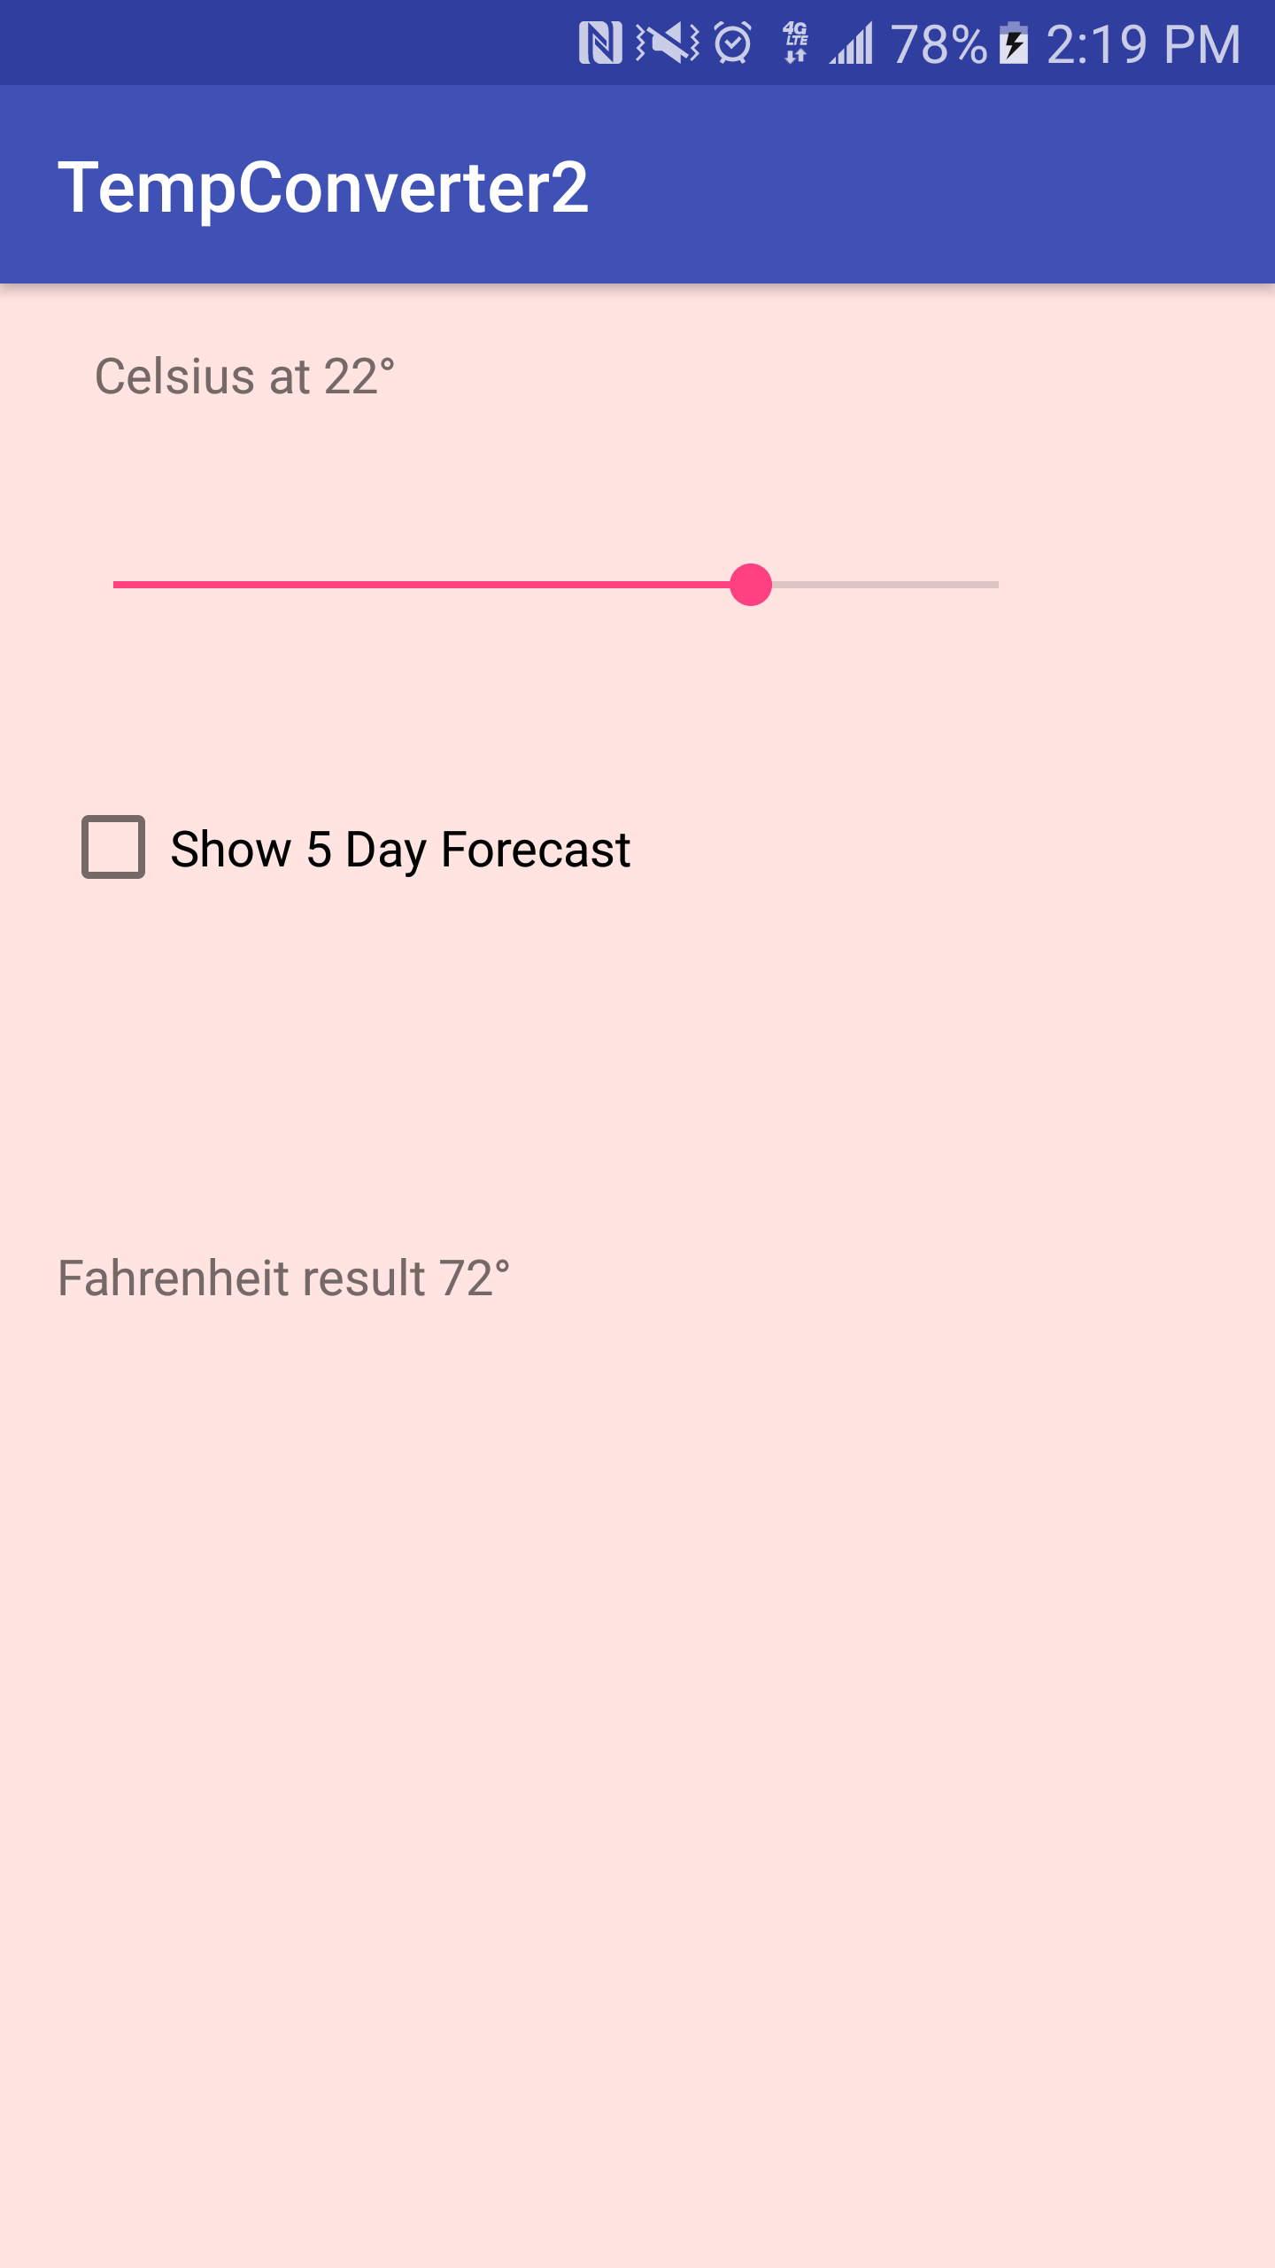

Snapshot 2: 5 day forecast view that’s rendered

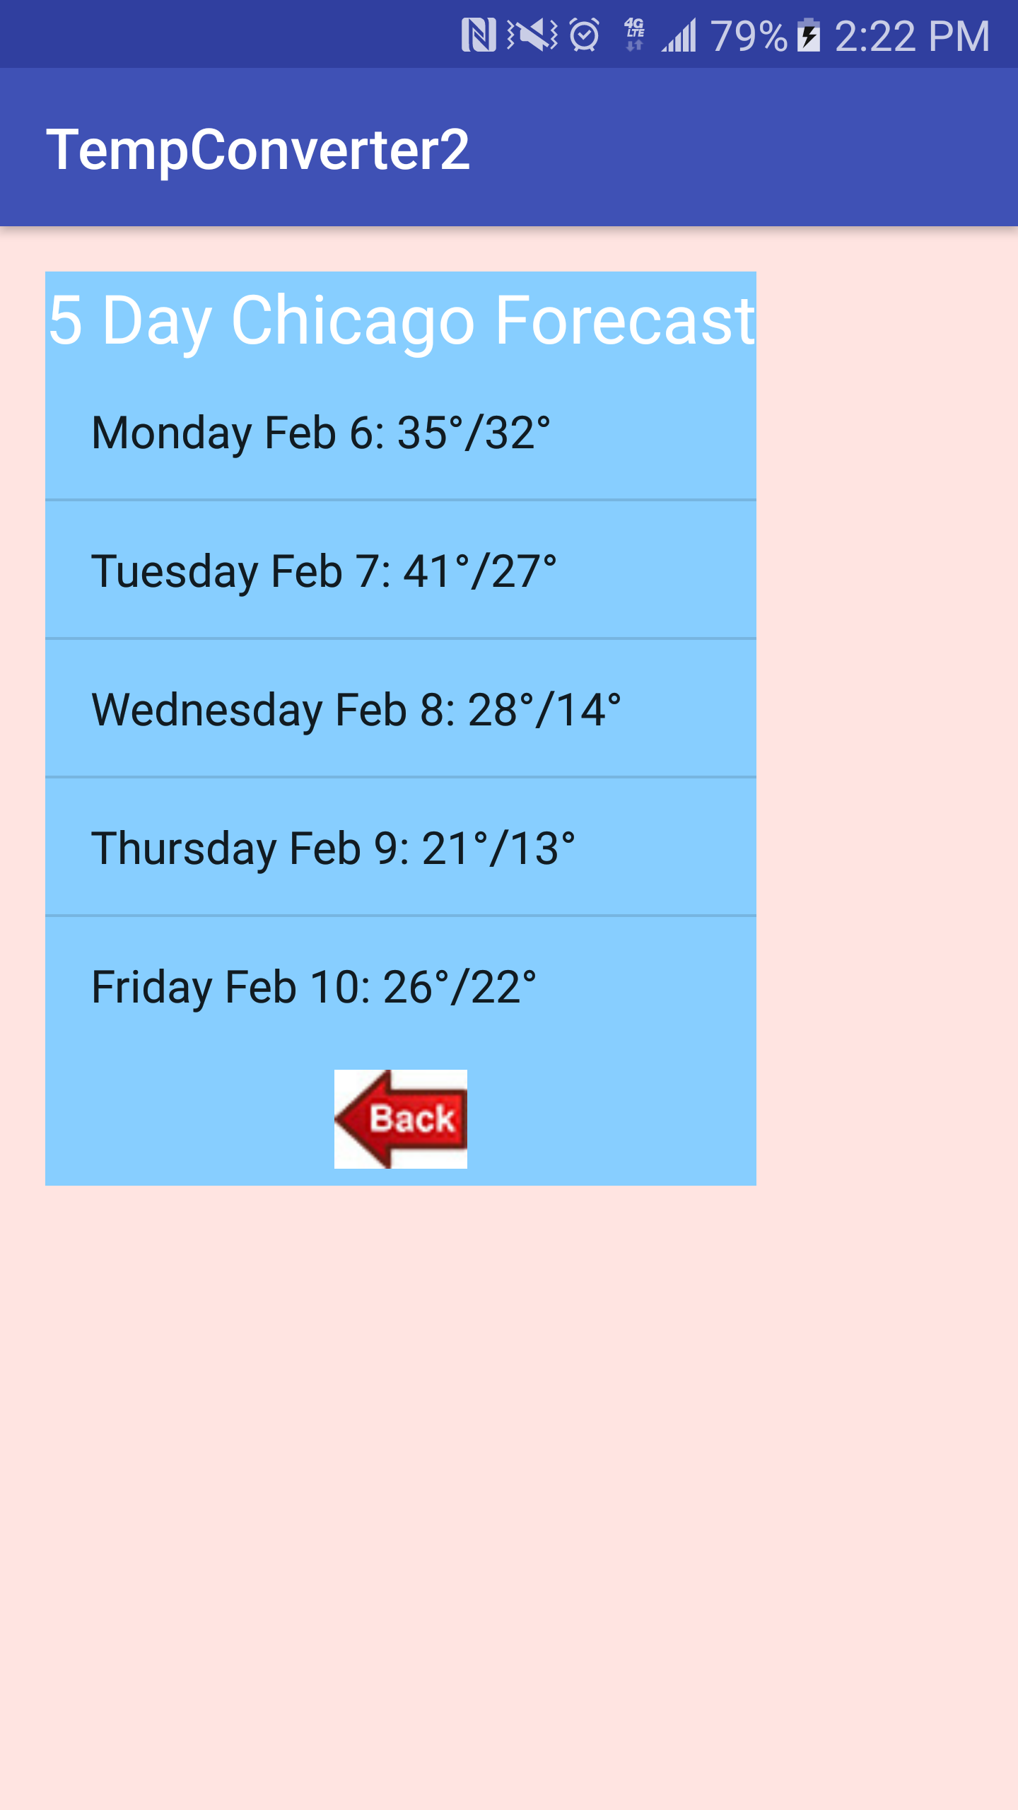

Snapshot 3: Result of your “Back” button in action

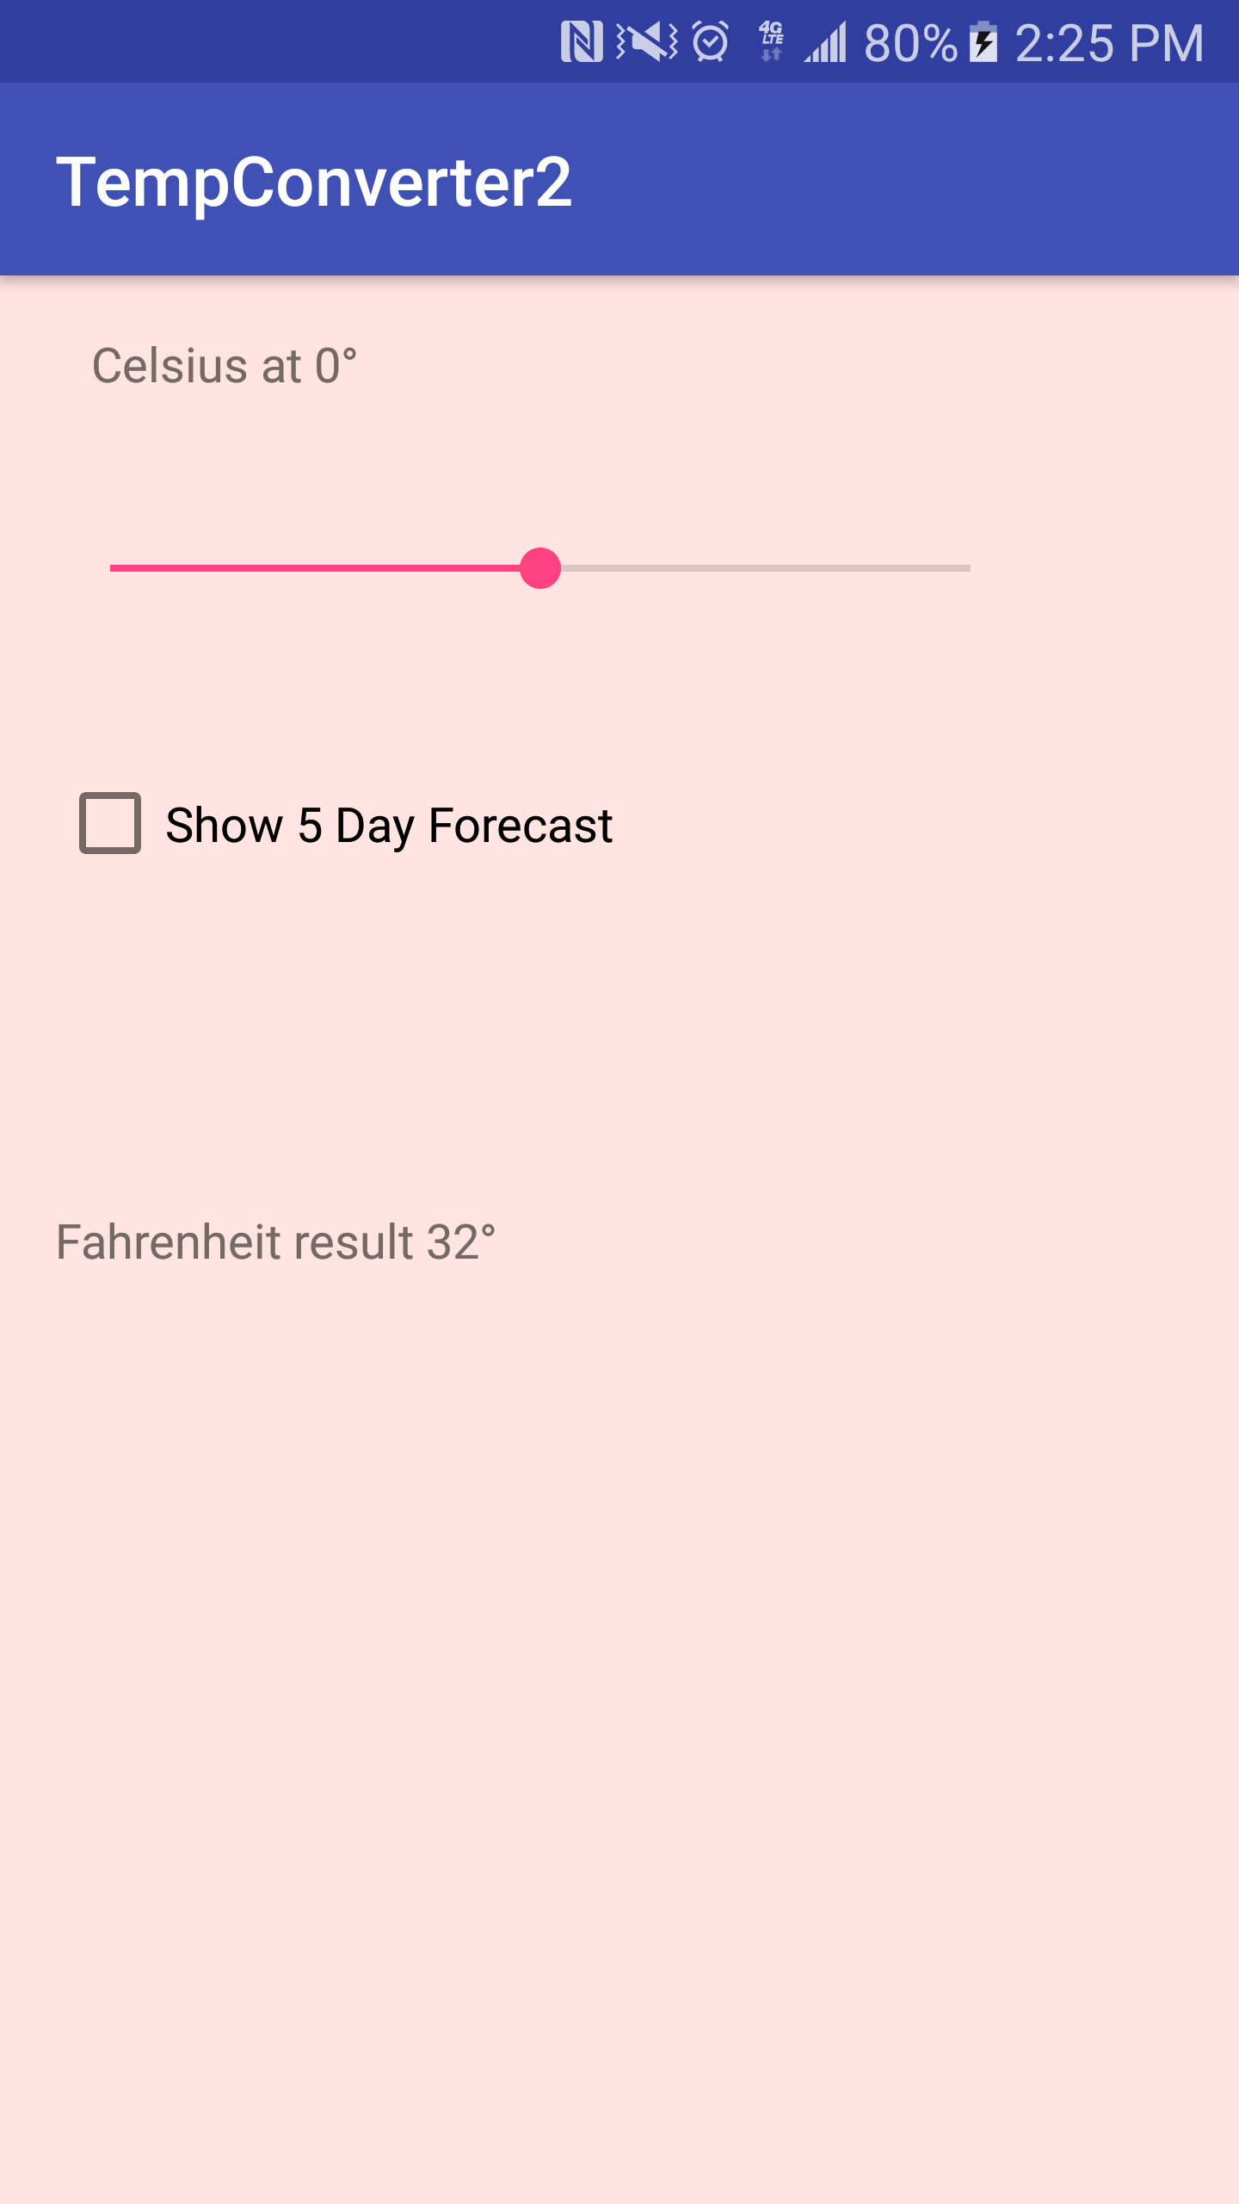

Snapshot 4: Home screen with Temp Converter2 icon

